
Services Profile
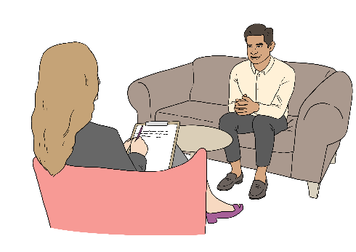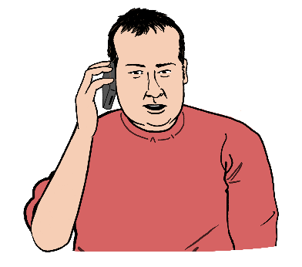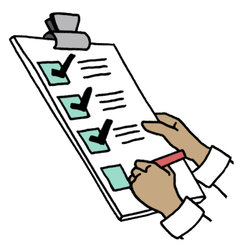
Your name

About this document
This document is made to help you communicate your needs when accessing a variety of services. These could include housing, education or employment support -whichever ones you need to use.
Inside, there are sections on:
- How you need to be contacted
- What to do if you don’t engage or respond to communication from services
- Your communication needs
- Your sensory needs
- How to help you during and after meltdowns and shutdowns
- Contact details for the services you are working with
- Information on what meltdowns, shutdowns, masking and stimming mean
- Links to other useful resources
Some questions require answers in text. Others can be answered by checking a box – to do that, just click on it and a cross will appear. You don’t need to fill in the whole profile. Just fill in whatever you are comfortable about sharing with services.
If you have any questions about using this profile, please email the Leeds Autism AIM team at leedsautismaim@advonet.org.uk.

 | 1. How I need to be contacted  Information on how to contact me in the most accessible way
Text Message |  | ☐ | Email | ☐
Letter |  | ☐ | Phone Call - It is alright to leave me a message if I don’t answer | ☐
Video call |  | ☐ | Face-to-face | ☐
Phone call - please do not leave me a message if I don’t answer |  | ☐ | Alternative augmented communication e.g. British Sign Language, symbols, photos | ☐
Notes about how I need to be contacted
 | 2. What to do if I don’t engage/reply to communications/attend appointments:  Please tick any boxes that would be helpful for you.
Send me a Text Message giving me clear instructions of how to move forward and get back to the service |  | ☐ | Send me an Email giving me clear instructions of how to move forward and get back to the service | ☐
Send me a Letter giving me clear instructions of how to move forward and get back to the service |  | ☐ | Phone me so we can talk about what I feel has caused me to disengage. Please leave me a message if I don’t answer | ☐
Phone me so we can talk about what I feel has caused me to disengage. Please do not leave me a message if I do not answer |  | ☐ | Reassure me that it is alright to come back and attend the service | ☐
Keep Trying – It may take multiple attempts to get through to me due to my anxiety |  | ☐ | Contact this person on my behalf:  Name:  Phone number:  Email address: | ☐
If I don't respond to an email within 24/48 hours, please send me a text in case my internet access has been interrupted |  | ☐
Other: Please write below |  |  |  | ☐

 | 3. Communication needs  Say how you need to communicate and how services should communicate with you
How I Communicate – please tick any boxes that apply. You can also add rows to this section by moving your mouse near the edge of this table and clicking on the plus sign in a circle
I need to use text chat | ☐ | I need to use video calls | ☐
I need to communicate via email | ☐ | I need to meet face-to-face | ☐
I have dyslexia | ☐ | I have dyscalculia | ☐
I have a learning disability | ☐ | I have dyspraxia | ☐
I need written instructions | ☐ | I need information in bullet points | ☐
I need British Sign Language (BSL) | ☐ | I need in formation in Easy Read | ☐
I am blind or partially sighted | ☐ | I am non-verbal | ☐
I need printed information on pastel-coloured paper e.g. pale yellow or lilac/lavender | ☐ | I need extra time to process information being given to me verbally | ☐
I need background noise to be turned down when speaking on the phone/via video call | ☐ | English is not my first language – please write your first language in the box below | ☐
I have trouble reading small print / I need large print | ☐
I need extra time to process info | ☐
How to communicate with me – please write down in this box
Examples: Please give me time to respond to a text message to process what you have said; try not to use metaphors as I find it hard to picture them
Additional communication needs – please write them down in this box e.g. needing to be in a quiet room when meeting someone face-to-face

 | My emergency contact  Please only fill this in if the service you are accessing doesn’t have your emergency contact details
Name |  |  |  | Email
Role |  |  |  | Phone no.
Relationship to you |  |  |  | Address
Do they have your consent? |  | Yes ☐ | No ☐ | Postcode

 | 4. My sensory needs  How you experience sound, smell, light and other senses, as well as how services can support you to meet your sensory needs
I am sensitive to bright lights | ☐ | I am sensitive to bright colours | ☐
I am sensitive to strong smells e.g. cleaning products, from cooking | ☐ | I do not like to be touched | ☐
I am sensitive to loud noises e.g. music played from speakers | ☐ | I need access to a quiet space | ☐
I need loud noises or music | ☐ | I need access to a darkened room | ☐
I need access to bright lights or colours | ☐ | I need access to something I can smell e.g. scented candles | ☐
I need access to fidget toys e.g. fidget cubes | ☐ | I am overwhelmed when in busy environments | ☐
I have allergies – please write in the box to the right | ☐
Please write down details of any other sensory needs you have in the box below:

 | 5. How to help me in meltdowns and shutdowns  Please let us know how you would like to be supported during and after you have a meltdown or shutdown e.g. needing to be left alone in a meltdown.  More information on meltdowns and shutdowns can be found on the Useful Information page of this guide. You can add more rows to this section if you need to.
How to help me during a meltdown or shutdown e.g. give me space, don’t talk to me when I am having a shutdown |  | How to help me after a meltdown or shutdown e.g. give me access to a quiet or darkened room, give me recovery time

 | 6. Service I am currently working with  In this section, list the services you are working with, including their contact details and what they are doing for you. Write down as many services as you like in this section.
Name of service:
What they are helping you with:
Name of contact from the service:
Email address:
Phone number:

Name of service:
What they are helping you with:
Name of contact from the service:
Email address:
Phone number:

Name of service:
What they are helping you with:
Name of contact from the service:
Email address:
Phone number:

Name of service:
What they are helping you with:
Name of contact from the service:
Email address:
Phone number:

7. Useful information: Definitions
Meltdowns: An intense response to an overwhelming situation. It happens when someone is completely overwhelmed by their current situation and temporarily loses control of their behaviour. This can be expressed verbally (e.g. shouting, crying), physically (e.g. kicking, lashing out) or in both ways – National Autistic Society
Shutdowns: They are involuntary responses to being overwhelmed. Whereas meltdowns usually result in an external reaction (more of a 'fight' response), shutdowns can be more internal (more of a 'freeze') but one can lead to the other. It means that stress, overwhelm and exhaustion is so high that our brains and bodies literally shut down. This can look different for different people – Authentically Emily
Masking: Masking is a strategy used by some autistic people, consciously or unconsciously, to appear non-autistic to blend in and be more accepted in society. It can happen in formal situations such as at school or work and in informal situations such as at home with family or socialising with friends – National Autistic Society
Stimming: Stimming or self-stimulating behaviour includes arm or hand-flapping, finger-flicking, rocking, jumping, spinning, head-banging and complex body movements. It includes the repetitive use of an object, such as twirling a piece of string, or repetitive activities involving the senses (e.g. repeatedly feeling a particular texture) – National Autistic Society
8. Useful self-advocacy and planning resources
The Advonet Group have self-advocacy resources that can help with things like planning for meetings, phone calls and making complaints:
- Meeting Planner – can help to plan for an important meeting
- Phone Call Planner – can help to prepare for any phone calls
- Complaints Template – this can help with making a complaint about a service you have recently accessed
There are tools on the Leeds Autism AIM and Bradford and Craven Autism AIM websites that can help you to speak up for yourself and your rights:
- Leeds Autism AIM: Self-Advocacy Tools – includes daily and weekly planners, a social profile and communication profile
- Leeds Autism AIM: Strategy Guides – guides on areas like work and health
- Leeds Autism Alert Card – a free alert card that can help you to tell people you are autistic when in stressful situations
- Bradford and Craven AIM: Self-Advocacy and Planning Tools – includes weekly and daily planners, a social profile and communication profile
- Bradford and Craven AIM: Info and Strategy Guides – includes guides on work and communication

