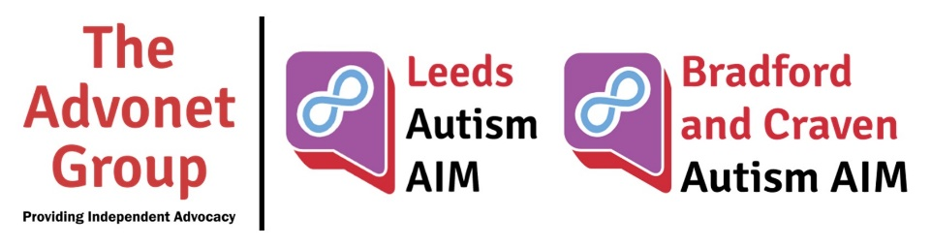
Autism AIM Self-Care Plan

Today, I will…
Read a book | ☐ | Take a shower | ☐
Treat myself to a mid-day nap | ☐ | Dress up | ☐
Draw | ☐ | Meditate | ☐
Binge watch my fave show | ☐ | Go for a walk | ☐
Call my friends | ☐ | Eat a healthy breakfast | ☐
Journal my thoughts | ☐ | Listen to music | ☐
Do something else (write in box to the right) |  |  | ☐

Stay Safe, Stay Well
Get Dressed  Simple comfort clothes will do! Maintaining routine will feel more productive and reduce some of the stress from this chaotic time. | Eat New Healthy Recipes  Eating a variety of foods and trying different recipes will give your day variety and keep your body feeling healthy.
Be Creative  Try new activities or bring back old ones, it’s a great way to keep your spirits up and your mind relaxed | Get Some Fresh Air  Fresh air will reduce the feeling of being stuck at home, even it means standing outside your door for a bit!
Switch Off  Everyone everywhere is talking about COVID-19. Switch off your gadgets and get some well-deserved time-out! | Stay Connected  Social distancing means visiting family and friends physically is restricted, so take advantage of video chats, phone calls and text messages!
Reach out
Mental health is always important and often overlooked. It’s especially important during difficult times like these. Reach out if you need to and remember to check in with friends and family. We’re all in this together.

