Guidance for practitioners on question patterns for working with autistic adults

Table of Contents
Introduction 2
Prepare 2
Points to consider 3
Useful Patterns of Questioning 4
Case Studies 6
Case Study A 6
Possible response to Case Study A 7
Case Study B 8
Possible response to Case B 9
Case Study C 10
Possible response to Case C 11

Guidance for practitioners on question patterns for working with autistic adults

Introduction
Every autistic person has different sensory environment, processing, and communication needs. There are some questioning patterns that do not work well with autistic people, so this resource is designed to provide some alternative examples that may work better.
It is also important to adjust your communication style and or sensory environment to meet their individual need. This will improve access to your service and help the individual feel listened to and less anxious.

Prepare
- First check whether they have a communication, processing and or sensory profile.
- Check whether they need any reasonable adjustments.
- If they need help with their profile, refer to them to http://leedsautismaim.org.uk

Points to consider

Context of processing needs – gauge which format the person prefers to answer and receive questions as this may alter your question pattern.
Auditory Processing Needs – The person may need questions and answers to be written, texted, drawn or emailed. This could be prior to or during the session depending on agreed arrangements.
Information Processing Delay – The person may need questions and answers repeated or explained in greater contextual detail for their own clarity.
Sensory Processing Distractions – Aim to uphold the patient’s specific sensory needs by confirming their sensory profile and ensuring the environment is suitable for undistracted questioning e.g. closing windows to avoid background noise or turning off a fan if it would cause discomfort.
Masking – Please be aware that many autistic people may mask autistic traits to fit into a neurotypical centric environment. This could mean spotting stressors, discomfort or misunderstanding may be more difficult during consultation.
Avoid open ended questions – Please remember that using how and why type questions could be confusing to some autistic people. Be aware, they may still answer the question, without fully understanding the context of it.
Stimming – Be aware that your autistic patients may exhibit stimming behaviour and feel soothed by self-stimulating actions, such as hand flapping, using fidget items, spinning, or jumping and repetitive noises, or motions.

Useful Patterns of Questioning

And/ Or Patterns:
- The use of and/ or question patterns can help autistic people to contextualise their experience and pain more clearly.
- Example: Is the pain a squeezing or stabbing pain? Can the pain be felt in your muscles and joints?
Closed Questions:
- If an autistic person is less comfortable verbalising during a session or providing limited responses, then closed questions may direct the conversation.
- Example: have you had headaches in the past week? If not a headache, then would you say that you have experienced discomfort in your eyes?
- The patient may also benefit from a quiet space that they can relax and destress in ready for the appointment.
Experience-led Questions:
- Autistic individuals may have specific ways of expressing pain, discomfort and illness due to the ways in which we perceive our senses.
- If the professional has assumptions about a certain sense or pain experience, then it may be useful to ask the autistic person about their own profile of sense or pain
- Example: how do you express your digestive discomfort? What does your abdominal pain look and feel like to you?
Patient-led Inquiry:
- Certain autistic people can be very communicative and direct, as such they may provide insight into their own condition through their lines of questioning.
- Professionals can coordinate with the sometimes inquisitive and pattern spotting behaviour of autistic patients because it can be a tool for better rapport.
Context and Consent:
- Professionals should utilise context as a means for communal understanding during consultation, be considerate of terminology and consent within questioning too.
- Example: When you say you laid in bed after the social event, would you say this was an autistic shutdown or something physically exhausting? Do you feel comfortable explaining what you felt after the social event?
Conversation Balancing:
- Please give the autistic patient space and time to respond during questioning as certain autistic people may have processing delays.
- Although, be aware that autistic people can take conversations on tangents and that steering the consultation back to the issue or topic at hand may be required.
Set Expectations: Set expectations for questioning or examination and provide direction on the plan ahead at the end of the session in the patient’s preferred format e.g. email, written or drawn.

Case Studies

Case Study A
A patient arrives uncomfortable and anxious, the patient is stimming and keeps looking to the bright desk light, as well as appearing distracted by the ceiling fan. You have tried to ask them open questions about their knee pain, but the patient keeps talking about their bus timetable rather than the health issue. 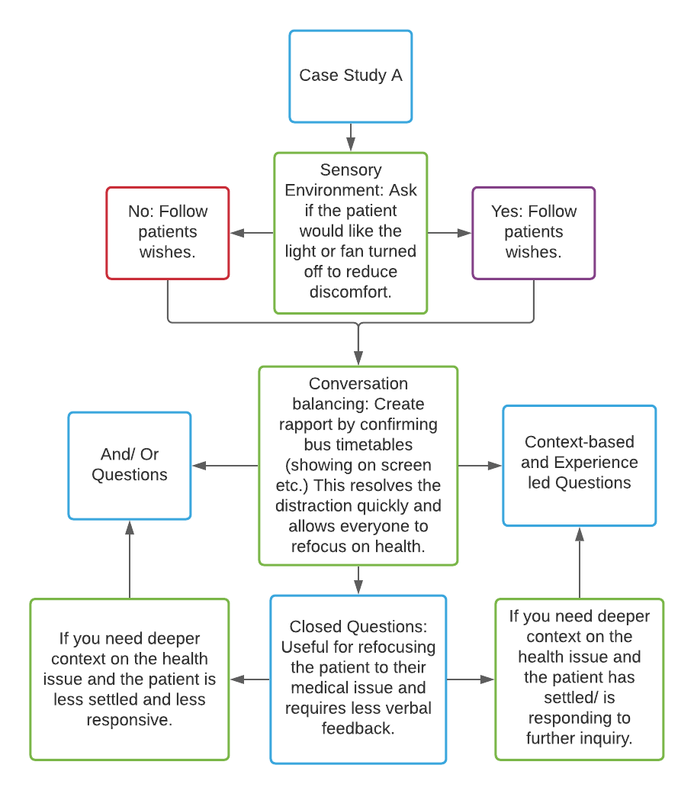

Possible response to Case Study A
Sensory environment: Firstly, you will need to address the patient’s discomfort in order to improve their responsiveness to your questions. Ask if the patient wants the environment changing e.g. turn off the bright desk light and distracting ceiling fan to limit sensory sensitivities. The patient will feel more understood if you consider their sensory needs and check their preferences before changing the sensory environment.

Conversation balancing: You will also need to calmly redirect the conversation back to questions about knee pain, but first show compassion for their concern about the bus timetables. This is a moment to create rapport with your patient, you can offer reassurance by confirming the bus schedule and which bus they may wish to take after your appointment. By simply resolving one issue of discomfort, you have instilled some trust between GP and patient.

Question pattern options: The patient arriving restless and distracted may require closed questions to refocus the consultation at first e.g. is your knee pain a regular occurrence? Does your knee pain last for more than a couple of hours? Once you have a supplementary understanding of the knee issues, you may wish to expand upon the context and use and/or questions to help the patient express specific details about their health concern. If the patient is confused by the and/ or question pattern you can switch back to closed questions or change to an experience-led approach. When examining pain descriptions with the patient, sometimes acting out or visualising the actions of pain may be useful e.g. squeezing pain emoted by clenching and unclenching a fist etc. Always try to adapt to the patient’s needs, meanwhile, try to be conscious of any reasonable adjustments they may require.

Case Study B
The patient is quiet, checking their phone and they are not emoting upon arrival to the consultation. The patient is here to have a routine prescription check-up, but they remain unresponsive after the first few attempts to start up verbal conversation.
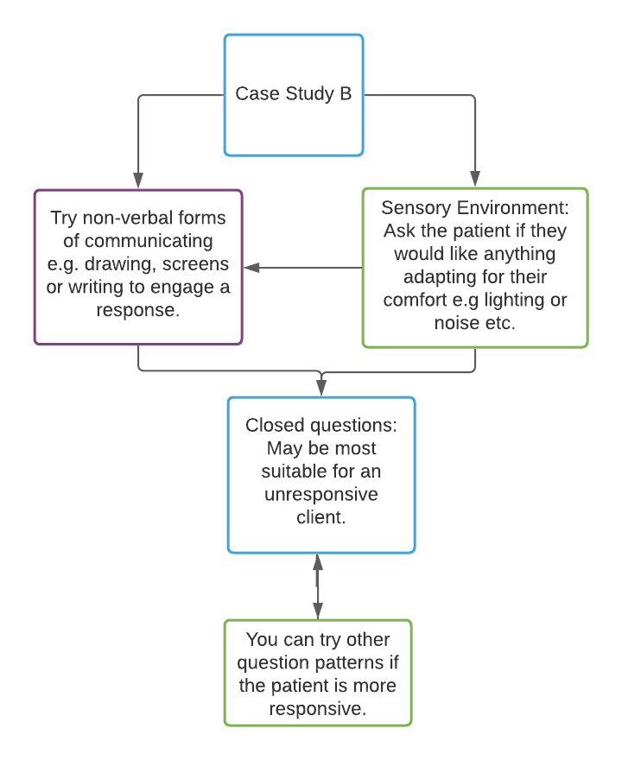

Possible response to Case B
Non-verbal Communication: Do not become frustrated if the patient does not respond verbally, autistic patients may need alternate forms of communication in order to engage with your consultation. Please try writing, storyboarding or drawing your initial introduction and questions down, then share this with your patient. Ask them if they prefer written communication for questioning and answers, or whether they would rather you ask them verbally and they respond on paper or via a screen provided.
Question Pattern Options: Remember to try different question patterns no matter the format and ask the patient which pattern they feel most comfortable with. Closed questions for a patient who is less responsive may be the easiest and least stressful starting point. However, the patient may also need some time to settle in the appointment and destress in a quiet space.
Set Expectations: Once the format has been agreed and you have been able to engage the patient in dialog, clearly explain what is needed during this consultation for a prescription review. Providing autistic patients with an outline for routine examinations or standardised questioning can help to reassure them and provide easy expectations to fulfil during consultation.

Case Study C
Patient C is very talkative and has arrived with a list of written questions, as well as extremely detailed examples of each of their symptoms in diary format. They interrupt your questioning and often take control of the consultation but have become repetitive.

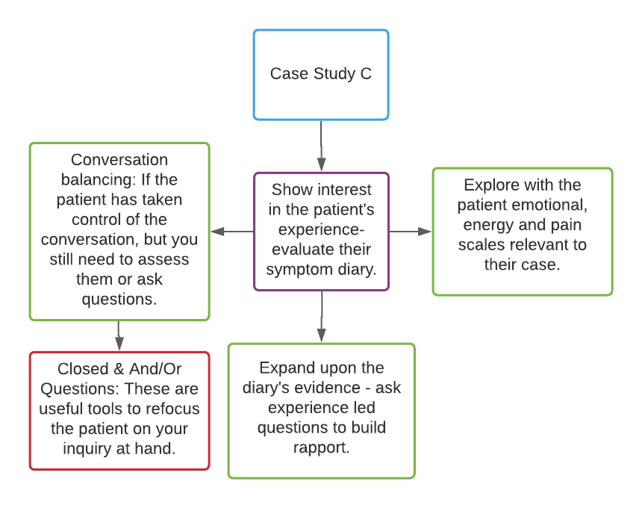

Possible response to Case C
Experience Led-Inquiry: The patient is offering you lots of contextual and experience-based information which is vital and should be valued. Make the most of the written symptom diary for useful patient-led inquiries, however, you will need to redirect the conversation in order to answer their written questions more directly. Reiterate your interest in the patient’s experience since they have clearly taken extra care to communicate with you in multiple formats.
Conversation Balancing: However, if the patient begins to repeat symptoms and concerns, then this is a signal for you to steer the conversation back to your analysis. If the patient starts to fixate, then asking closed or and/or questions may provide the structure needed to refocus e.g. ‘Thank you for the time you have taken to compile this symptom diary, the diary is helpful. I would like to know does the earache noted remain constant during episodes or does it build in intensity?’ Feel confident explaining any of your terms used and please look to our AIM Autism Pain Scales to examine the severity or intensity of pain with autistic patients. Although, your patient may also require some time to process information or appreciate repetition.
Reminder: Please remember that these questions patterns are standardised and simplified examples of possible scenarios and that these can be tailored for specific patients alongside the use of other autism specific resources e.g. autism passports, pain and fatigue scales, as well as symptom diary templates. Please refer to our clinical training video if you need a refresher on autistic experiences and client needs.

