Spoon scale for expressing pain

Context: Expression of pain and fatigue can be difficult for autistic people when asked to use vague pain or fatigue scales. This pain and fatigue scale uses the concept of spoons to represent the amount of energy that you have and how much energy your pain or daily tasks are using. This can be adapted so that it best represents how you experience pain or fatigue. For example:
- How often or how long you have been experiencing this pain or fatigue,
- Specific language that you would use to describe pain or fatigue,
- Specific tasks that you are unable to do,
- Storyboarding or acting out the spoon scenario (keep a pack of spoons available, if possible),
- Colour code the scale such as a traffic light system.

What is spoon theory?
Spoon theory is used to describe the amount of physical or mental energy a person uses to complete their daily activities and tasks. When using this resource let’s say on average a healthy person starts the day with 30 spoons, whereas a chronically ill person may start the day with 15 spoons for the same tasks.
Also, certain tasks may cost different people varying amounts of spoons. Autistic people may have additional costs and barriers to tasks due to their specific communication, processing or sensory needs.
Comparative example: Olga, who is neurotypical may take a shower in a gym using 2 spoons, but for Bob who is autistic and has specific sensory needs, often facing uncertainties in an unfamiliar or crowded environment, then he may use 6 spoons to have the same shower at the gym.
Simplified example: Bob uses 4 spoons to brush his teeth, six spoons to have a shower and 5 spoons to get dressed. Once Bob has used all their spoons for the day, then they have no energy left to complete daily tasks.

Spoons Scale

 | I have no spoons left and I have no energy at all.
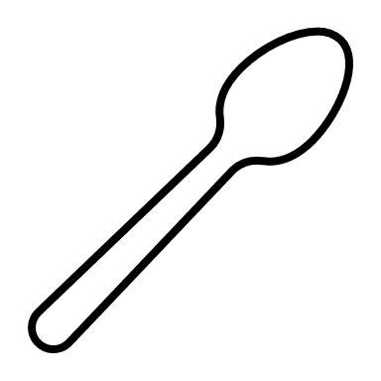 | I have very few spoons and I am often feeling exhausted.
 | I have used a lot of my spoons and I am finding that I have little energy.
 | I have used some of my spoons, but I am able to complete most of my activities with a break.
 | I have all my spoons and I am able do my usual daily activities.

Please note that the scales are designed to look at the impact on the individual rather than specific symptoms and where someone is on the scale can fluctuate over time.

