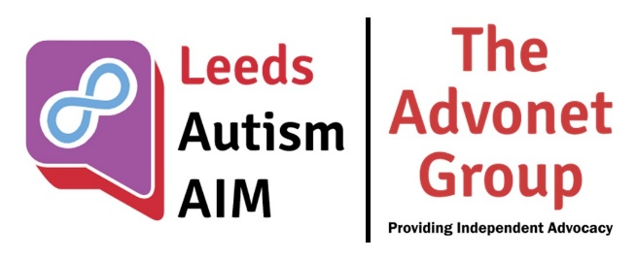
Coping in Winter: A guide
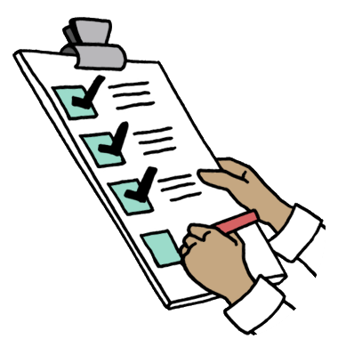
Winter can be a very difficult time of year for many people. Whether you are at home, commuting to work or out running errands, if the weather is snowy and the ground is covered in ice, it can be hard to know what to do to be safe.
This guide from the Leeds Autism AIM team has hints and tips on how to cope in winter, inside or out. Below, there is a checklist of items you could have handy, then a list of tips for coping at this time of year.
Checklist of items
Items you might need | Have I got it?
A warm coat | ☐
A pair of gloves | ☐
A scarf | ☐
Legwarmers/long johns | ☐
Warm socks | ☐
Draught excluder(s) | ☐
Snow shovel | ☐
Grit or rock salt | ☐
Warm drinks e.g. tea, coffee, soup | ☐
A flask | ☐
Blankets | ☐
A handheld torch | ☐
Hand warmer | ☐
Power bank | ☐
Wind-up, rechargeable or battery-powered radio | ☐
Bottled water | ☐
Wellington boots | ☐
Boots with plenty of grip on the sole | ☐
Batteries for your radio and/or torch | ☐

Warm clothing
If you need to go outside, it pays to have warm clothing. A thick coat, pair of gloves, scarf and, if needed, legwarmers or long johns would help keep the cold out in freezing conditions.
Indoors, putting on an extra layer can help you be warm. Blankets, throws or even a duvet can have the same effect.
Hot drinks
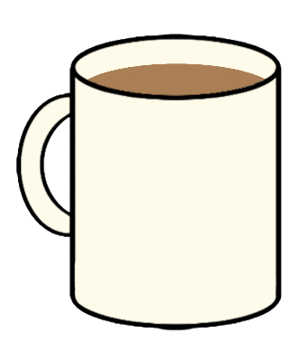
Either at home or inside a flask when outside, hot drinks can help you stay warm during a cold snap. Having a supply of tea, coffee and/or soup is handy in winter, especially if it’s too cold to go to the shops. Tinned and/or frozen food can help too if you’re snowed in.
Winter-ready footwear
If you need to dig snow from the pathway out of your home or have to walk on icy pavements, having appropriate footwear helps. Wellington boots are useful if digging snow or you want to keep your feet dry when on muddy ground.
For icy surfaces, boots that have plenty of grip on them can be useful. If you cannot find a pair, you could get some snow grips to put on a pair of shoes you already own.
Emergency supplies

If the winter weather is so cold that it leads to a power cut, having emergency supplies in case is worth doing. They include a radio for listening to music or local news updates, batteries, a power bank, a handheld torch, bottled water and a flask filled with hot water.
A first-aid kit containing items like plasters, bandages and paracetamol can be useful too, in case of injuries.
Keep up-to-date with weather forecasts news

Part of being prepared for winter is knowing when snow and ice are coming. To help with that, checking weather apps or websites might help. The Met Office’s smartphone app sends alerts if they are issuing weather warnings for snow, ice, rain or high winds.
Cold weather-related benefits
If you meet certain criteria, there are a couple of cold weather-related benefits that you may be eligible for. These are:
- Cold Weather Payment: https://www.gov.uk/cold-weather-payment
- Winter Fuel Payment: https://www.gov.uk/winter-fuel-payment
Citizens Advice have some links on their website to grants and benefits to help you pay your energy bills: https://www.citizensadvice.org.uk/consumer/energy/energy-supply/get-help-paying-your-bills/grants-and-benefits-to-help-you-pay-your-energy-bills/
Go out when you need to
If you feel like going outside, but don’t need to for any particular reason such as work, check the weather before making a decision. Waiting for snow or ice to melt is a good idea, especially if you have enough food, drink and toiletries to last you a few days.
Find a warm space
Throughout the winter, there are buildings across Leeds acting as warm spaces. They include places of worship, community centres and libraries. A map of warm spaces can be found here: Warm Spaces map for Leeds
Other warm spaces that might be worth visiting could include cafes, restaurants and shopping centres. Getting a hot drink at all three might help you be even warmer!
Being safe in emergencies
If gas, electricity or water stop running due to cold weather, it’s possible to get updates on when those services will start working again. Here are some useful links:
- Northern Powergrid – Powergrid Care: https://www.northernpowergrid.com/care - this is for anyone who needs the power on for medical reasons, or if they are sick, disabled or have trouble communicating
- Northern Powergrid – Power Cuts Map: https://www.northernpowergrid.com/power-cuts-map - this live map shows where power cuts are happening across Yorkshire and the North East. For each location, it says how many properties have been affected and when the power outage is likely to be fixed
- Yorkshire Water – Problems in your area: https://www.yorkshirewater.com/your-water/problems-in-your-area/ - a live map where you can see if there are issues with water in your part of the world
- Yorkshire Water – Priority Services Register: https://www.yorkshirewater.com/bill-account/priority-services-register/ - if you need to use more water than most for reasons such as disability, you can sign up for extra support from Yorkshire Water

We have produced a guide similar to this about staying warm and safe in emergencies such as power cuts. It has a checklist and some useful tips on how to stay warm and safe, including having warm clothing ready.  To see it, please scan the QR code on the right or go to https://tinyurl.com/aimstaysafe | 