
Staying safe and warm during emergencies: A guide
This winter, it is worth doing whatever you can to stay warm and safe. Whether it’s to keep the cold out or ensure you are not at risk in case of emergencies e.g. power outages, there are some things you could do. In this guide, we have listed ways to prepare for situations such as cold snaps and when any utilities stop working.
Checklist: What you could need to stay safe
Items you might need | Have I got it?
Batteries – AA or AAA | ☐
Power bank | ☐
Handheld torch or portable lamp | ☐
Radio – wind-up, rechargeable or battery-powered | ☐
Flask | ☐
Blanket(s) | ☐
Warm clothes | ☐
Draught excluders/weatherstrips | ☐
Bottled water | ☐
Things to keep you occupied e.g. books, board games, fidget toys | ☐
Have batteries and/or a power bank ready
In case they are needed to power portable appliances or gadgets like your smartphone, radio or a torch, batteries and a power bank can come in useful in emergencies.
Have a radio nearby
If the electricity is off and you want to know what’s happening, having a radio will help. You could use it for listening to local radio for updates on whether the power will go back on. Wind-up radios are really helpful in emergencies, but battery-powered and rechargeable ones are useful too.
Use a flask for hot drinks

In case the power goes off and you need a hot drink, fill up a flask full of hot water. This can keep water hot for a few hours and help you to make a warm drink or food like instant noodles.
Block draughts
At home, if there is a draught coming in from the doors or windows, there are simple ways to block them. For doors, a draught excluder is pretty effective. For windows, weatherstrips can help if you have any gaps around the frame.
Torches and portable lighting
To make sure you can see what you’re doing, a handheld torch is a must-have in case of power outages. Portable lighting such as rechargeable mood lights can help if you’re in the dark, especially if they can be charged via a USB cable.
Wear warm clothing
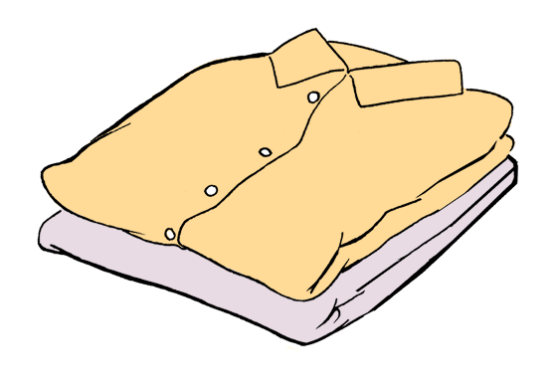
If you have any, wear warm clothes such as jumpers, jogging bottoms and robes. Wearing these and multiple layers can help you to feel warm if you’re unable to have the heating on. Blankets can help with this too.
Bottled water
In case the water goes off, have some bottled water handy. It could be for drinking, cleaning or cooking, but having some stored safely in your home is useful, especially during cold winter days.
Find something fun to do
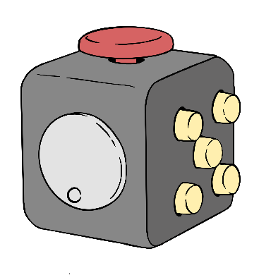
If stressed or anxious, it can be useful to have items like books, fidget toys or board games ready. They can help to take your mind off anything you are feeling during a power outage.

Useful links
- Touchstone: Leeds Winter Wellbeing Booklet 2022 – https://leedsautismaim.org.uk/wp-content/uploads/sites/7/2022/12/Leeds-Touchstone-Winter-Wellbeing-Booklet-2022.pdf
- GOV.UK - Top tips for keeping warm and well this winter: https://www.gov.uk/government/publications/keep-warm-keep-well-leaflet-gives-advice-on-staying-healthy-in-cold-weather/top-tips-for-keeping-warm-and-well-this-winter
- NHS - How to stay well in winter: https://www.nhs.uk/live-well/seasonal-health/keep-warm-keep-well/

