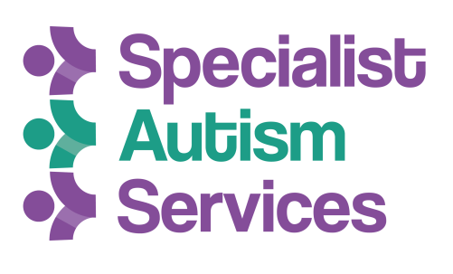

**Getting to Specialist Autism Services in Leeds**

*Our full address is:*

**Specialist Autism Services, Great Northern House, Junction 7 Business Park, Stourton, Leeds, LS10 3DQ**

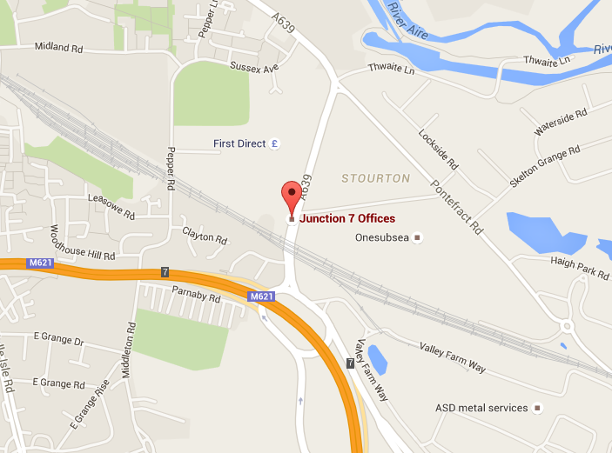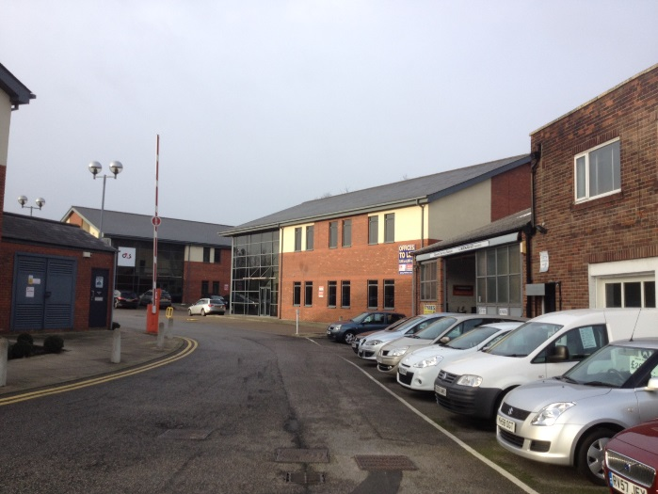

**The building from the entrance to site**

|  |  |
| --- | --- |
| http://tamarlimo.com/wp-content/uploads/2013/08/taxi.9485942.jpg | **By taxi** |
|  |

To arrive at SAS by taxi, give the taxi driver/company the following postcode: **LS10 3DQ**. It may also be helpful to tell them that the building is in the same small business park as MEARS and G4S. The entrance to the business park is opposite The Queens Pub on Wakefield Road.

|  |  |
| --- | --- |
| http://www.ford.com/resources/ford/general/newvehicles/Cars_Landing_Page/fiesta.jpg?v=1377238799000 | **By car** |

You can use a satnav/Google to locate our premises if you drive or get a lift with someone. Typing in the postcode **LS10 3DQ** should direct you to the building.

Alternatively you can get to SAS using these directions:

**From the M621:** Heading South on the M621, take the junction 7 exit. Take the first left on the roundabout and then take the second left (just before the Shell Garage) into the Junction 7 business park. SAS’s building is just to the left of the mechanic’s.

**From Leeds city centre (Crown Point Retail Park):** Head out of the city centre on the A61, passing the Leeds College of Building and Evans Halshaw on your leftand then Costco on your right. At the junction stay in lane for A61S taking you past a fish & chip shop on your left. Stay in the left lane (A639) and continue on A639 passing McDonald’s on your left, continuing past Kwik fit, also on your left. Eventually you will come to a junction, do not go (what appears to be) straight on (to Pontefract Road), instead bear to the right onto Wakefield Road. Turn in to the junction 7 business park on the right, just behind the Shell Garage and opposite The Queens pub. SAS’s building is just to the left of the mechanic’s

**Parking is available at the front and side of the premises. If you wish to park please request a visitors parking permit upon arrival.**

|  |  |
| --- | --- |
| http://www.open.ac.uk/about/estates/sites/www.open.ac.uk.about.estates/files/images/public-bus.jpg | **By bus** |

The following buses go between SAS and Leeds Bus Station:

**110 Arriva bus** – Leaves from Leeds Bus Station (Stand 9) every 10 minutes. This journey takes 11 minutes.

**444 Arriva bus** – Leaves from just outside the south entrance to Leeds Bus Station (York Street, stop F5) every 20 minutes. This journey takes 14 minutes. You can also catch this bus, earlier along its route, from Boar Lane, near to the train station (stop T1)

This means that roughly around every 5 minutes you can catch one of these buses from the bus station

***When boarding the bus, ask the driver to let you off at Queens Street on Wakefield Road.***

**What to look out for when on the bus** - About 5 minutes into your bus journey you’ll go under an ‘underpass’ (bridge) and see a McDonalds on your left soon after. You’ll also see a green car wash and a large Troy Foods warehouse on the journey. When you see a Skoda garage on your left you are nearly there. When you see a **blue car wash** on your left and a big **First Direct** building on your right press the button and get off at the next stop.

**From the bus stop**: cross over the road at the traffic lights. Walk along to the Shell Garage and turn right just past it (opposite The Queens pub) to enter the junction 7 business park. SAS’s building is just to the left of the mechanic’s.

|  |  |
| --- | --- |
| http://www.clipartlord.com/wp-content/uploads/2015/01/train24.png | **By train** |

SAS is based 2½ miles from Leeds train station. You can catch the **444 Arriva bus** from Boar Lane, near to the train station (stop T1) to get to SAS. You may want to walk to the bus station (about 10 minutes on foot) where there are more regular buses.

* * * * *

**Our Building has a security lock on the door. For access please press the buzzer to the right hand side of the door and wait for someone to let you in.**

**0113 277 56 56**

Steven.clark@specialistautismservices.org

Linda.langstaff@specialistautismservices.org