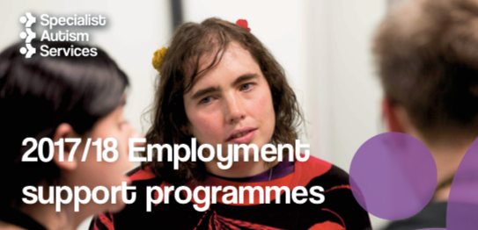

Specialist Autism Services

Employment Programmes

Information Sessions

Specialist Autism Services will be running two new employment programmes in Leeds from October 2017. One scheme is to help adults with autism apply for and successfully undertake apprenticeships. This will run on Tuesdays and Thursdays (you only need to attend one day each week). The other scheme is to encourage adults with autism to explore the possibility of self-employment. This will run on a Friday.

The information session will take place on Thursday 14th September, 1.30 - 3.30pm at Specialist Autism Services, Great Northern House, Junction 7 Business Park, Stourton, Leeds, LS10 3DQ. Buses go to The Queen's Stourton, are 110 (from Leeds City Bus Station, Stand 7), 444 and 446 (both from York St, Stop F5). We are behind the Shell Petrol Station opposite the Queen's Hotel in Stourton (which in turn is just past First Direct).

These sessions are open to adults with autism, their carers and supporters. You can sign up for either programme even if you can't attend the information session.

For more information on the information session or the employment programmes, including how to join please contact [employment@specialistautismservices.org](mailto:employment@specialistautismservices.org)

or call Wil Quick 07962 536928